# How to manage masternode sharing on Crypos

In this guide we will explain how to use Crypos.io for shared masternodes.

Now let's go to our browser and type [crypos.io](http://crypos.io/) in the address bar.

Then we register or log in if we are already registered.

Now that we are logged in, click on **shared masternode** in the left menu.

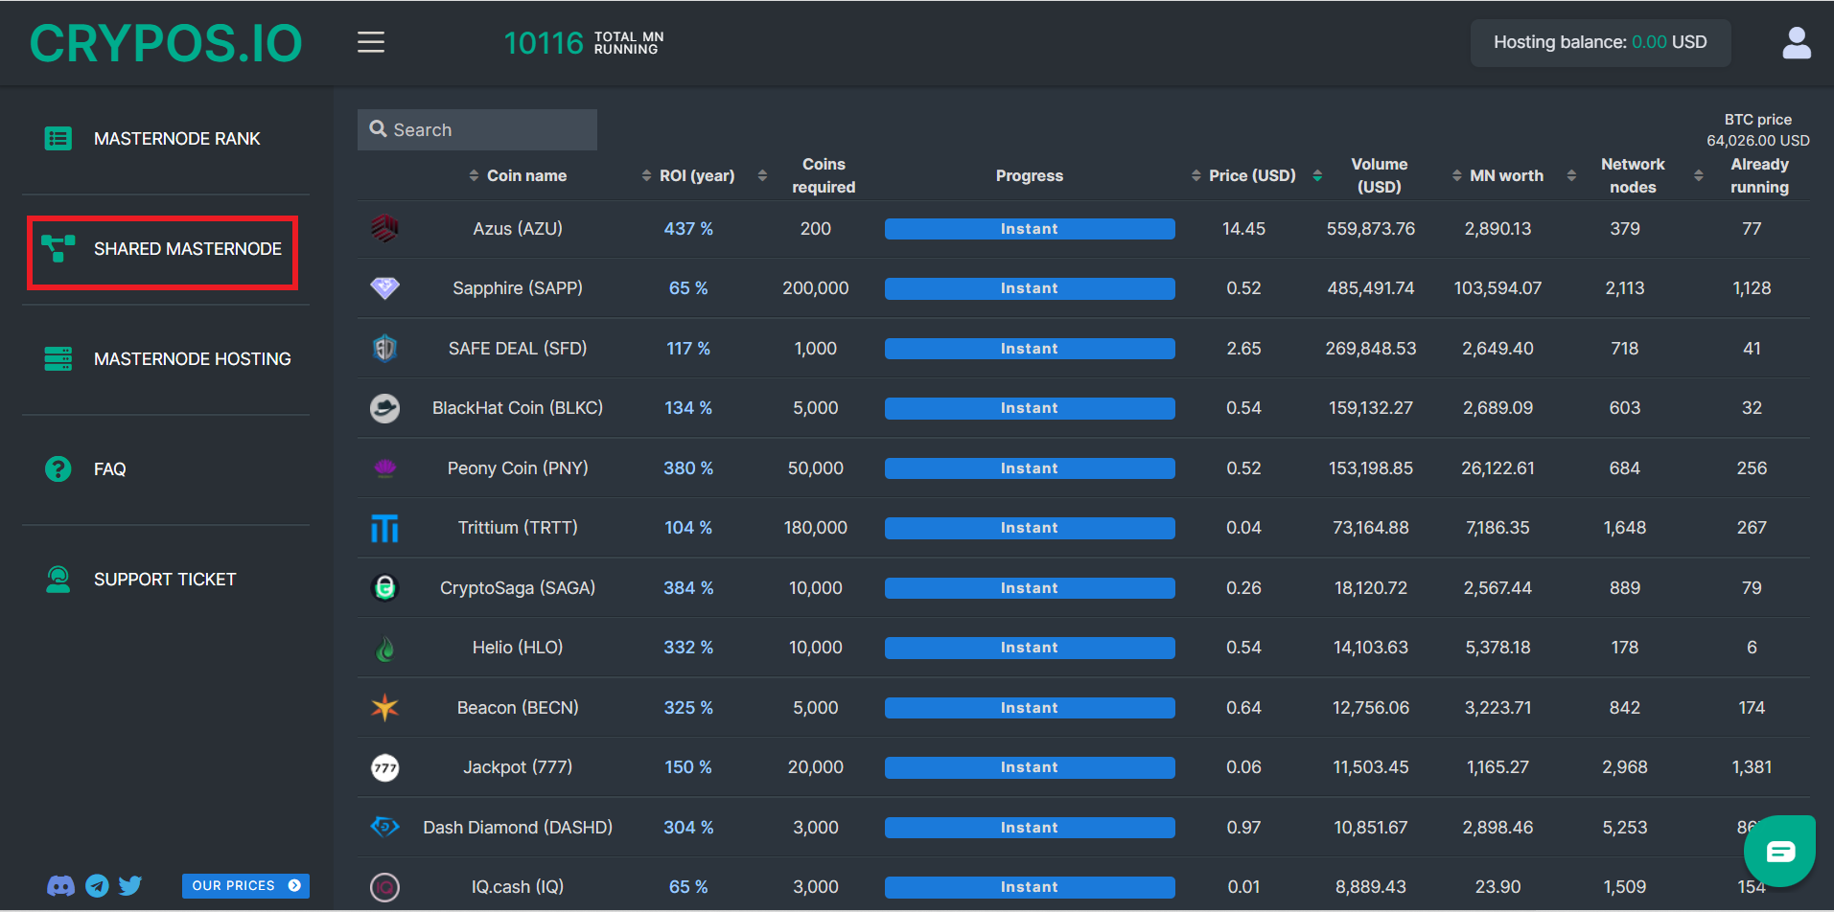

Once this is done, a page will open where we can choose the coin that interests us (in our case we choose Trittium).

Then click on the **Buy Share** button.

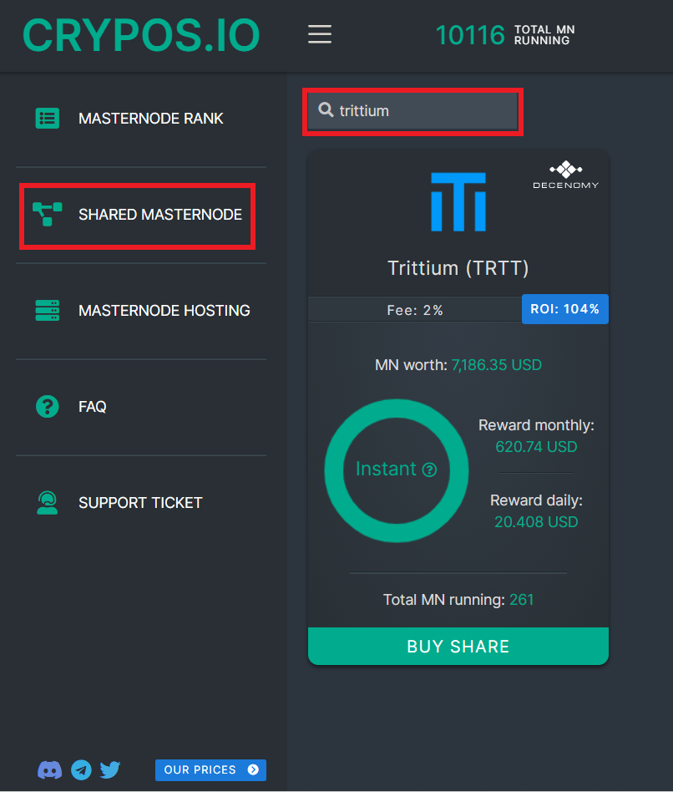

Before proceeding (as we will see shortly) it will be necessary to provide the receive address of our wallet, where our rewards will be sent if they are not all reinvested.

So now let's go to our wallet and from the receive menu we copy our address.

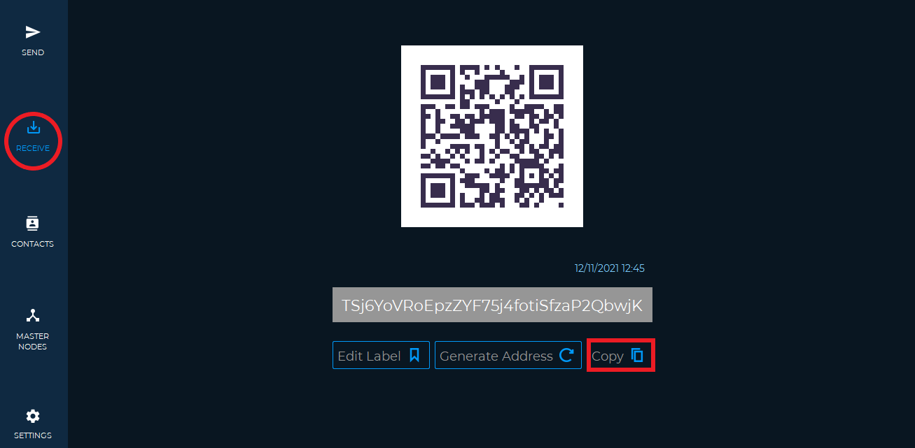

Now we can paste the address previously copied on the Crypos website, as shown in the image.

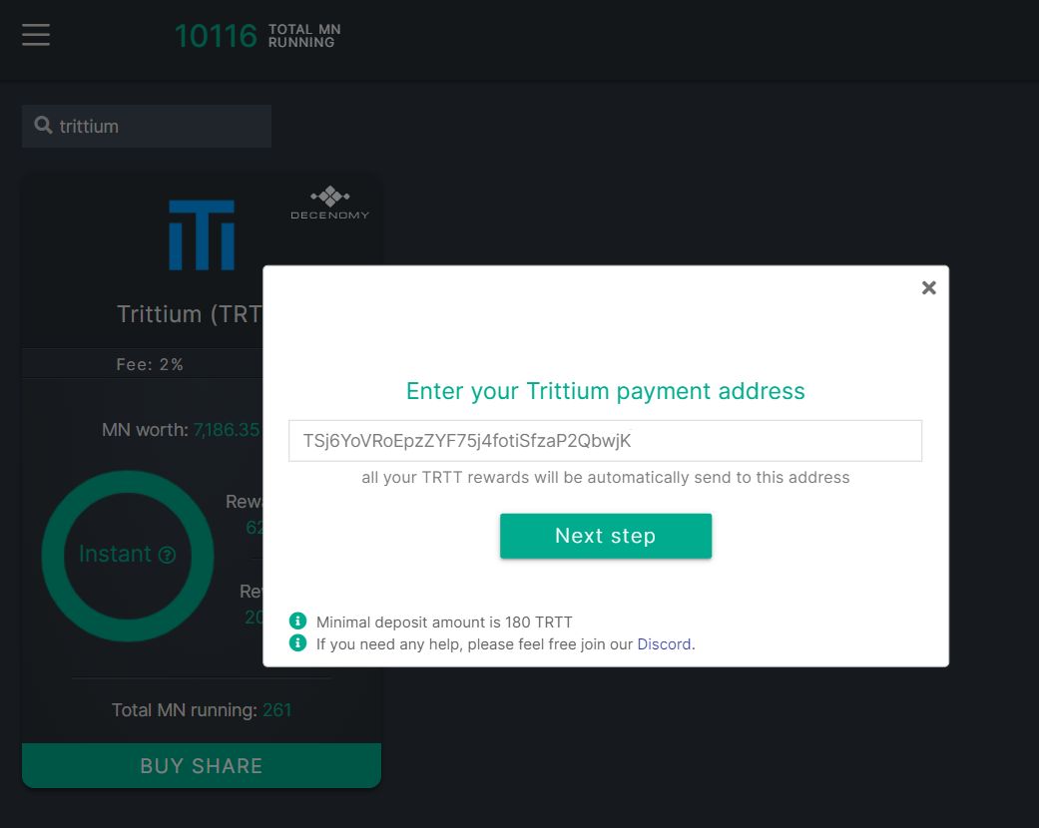

In the next step we can see the address to which we have to deposit our Trittium and choose the amount of rewards we want to reinvest (we have chosen 50%).

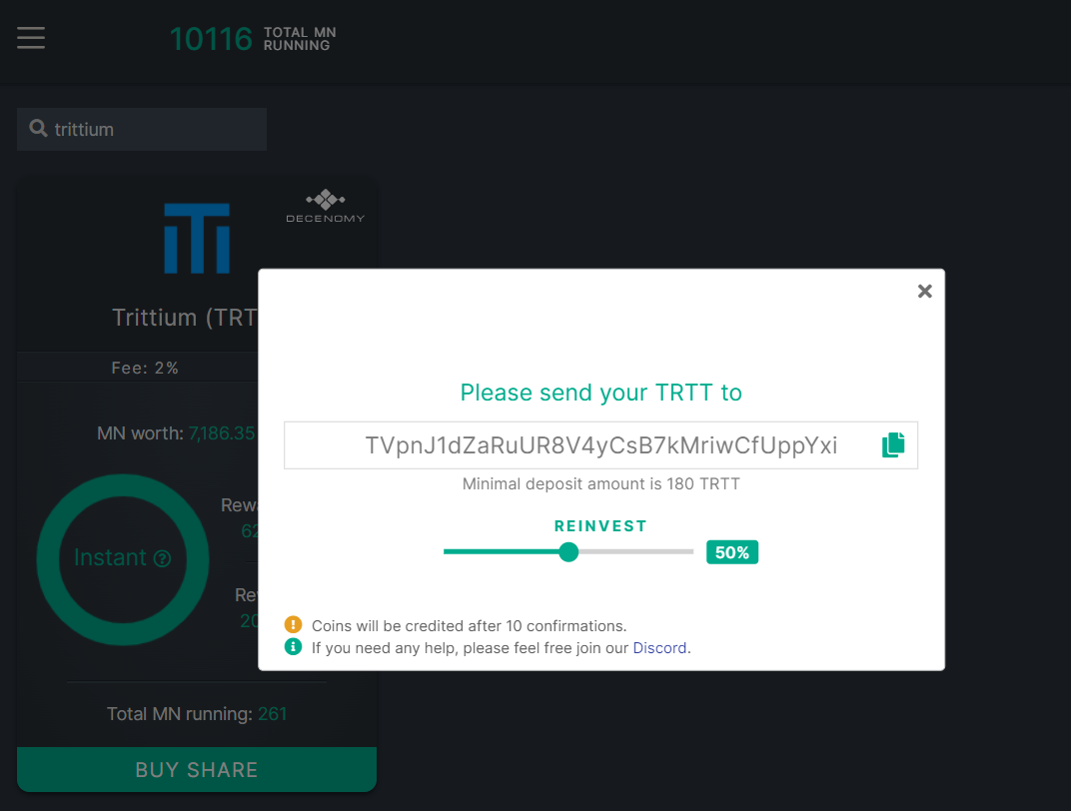

Now we send from our wallet to the address we see on Crypos, the coins we intend to invest.

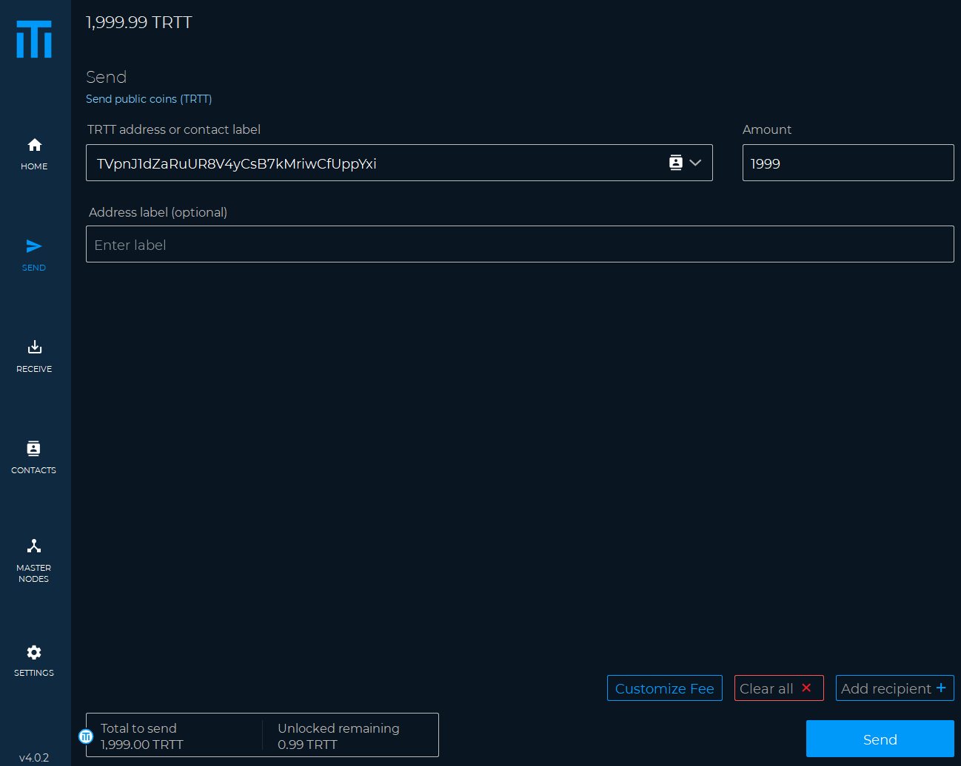

The coins will be credited after 10 confirmations.

Reached the 10 confirmations we will see our masternode by clicking on the icon at the top right and then on the item **my masternodes**.

Now click on the details button.

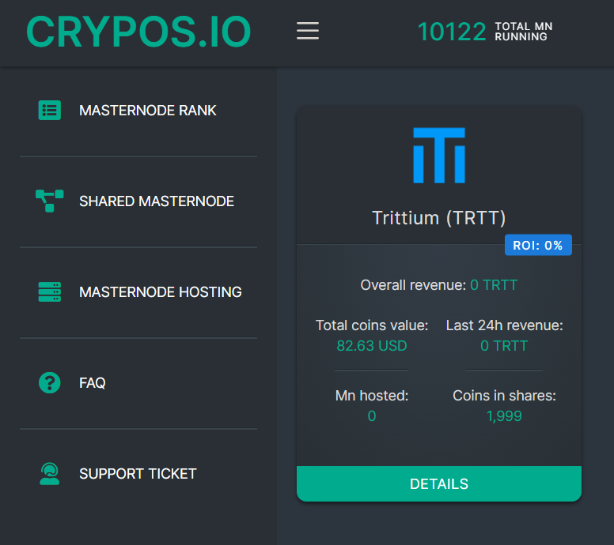

On the next page we can see the following information.

* Coins in shares (The coins we have invested)
* Coins value (The dollar value of our investment at the current price)
* 24h revenue (Expected returns in 24h)
* Overall revenue (Is the value of our earnings)
* ROI real (The real return on our investment)
* Reinvest (Here we can change the % of our reinvest value)

Below we can see the list of masternodes in which our coins are invested.

We can withdraw our funds at any time by clicking the icon highlighted in the image at the bottom right.

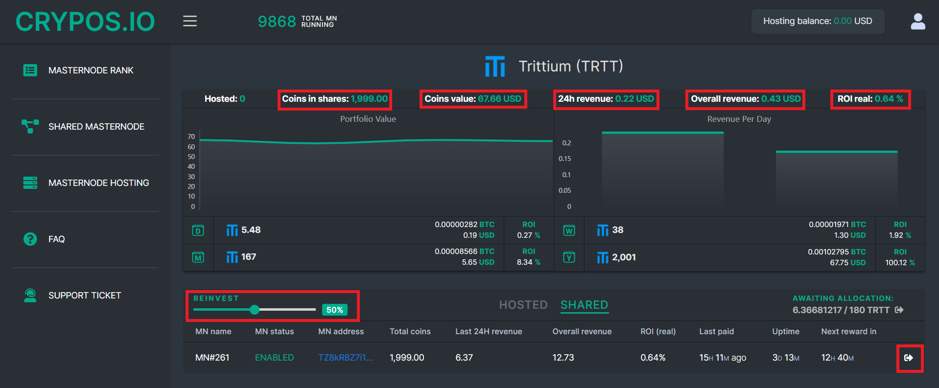

By going to our wallet we can check our received rewards.

